Field Office Processes

Table of Contents

- Communication Flow Chart

- Purchase Orders

- Weekly/Bi-Weekly Statements
- Large Contractors
- Smaller Contractors

- Invoicing

- Accruals Reporting

- Change Order Management Flow Chart

- Field Tickets (UPI/Extra Work) and Third Party Tickets Flow Chart

- Roles and Responsibilities for Tickets, Statements, Invoices

- Types of Back Up

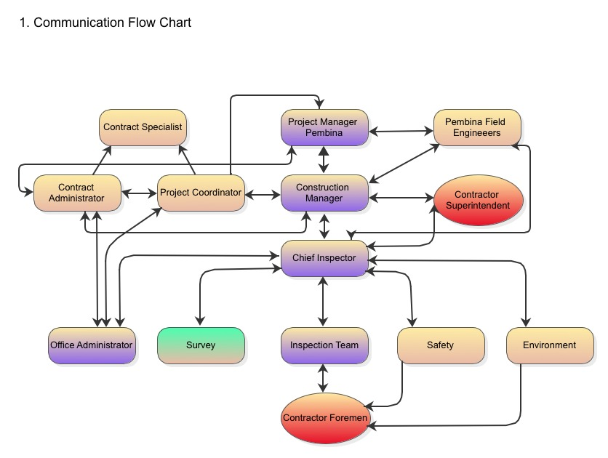

Notes:
Morning meetings- Inspectors relay previous days’ work to highlight or raise flags regarding potential reimbursable extra work to the Construction Management Team.
Extra work discussed by Contractor, Chief Inspector and Construction Manager (CM) will be relayed by the Chief Inspector to the field Inspectors and Office Administrators. This will facilitate knowledge transfer so inspectors know what they could be signing for in the field, and also provides the Administrators with information on what extra work has been approved/not approved.
Engineering, Land, Environment and Safety communications flow through the CM and Chief Inspector to Inspectors and then to Contractor foremen in the field. CM and Chief Inspector have direct lines to the Contractor Superintendents and Project Managers. The Construction Manager has a direct line to the Project Manager.

Ongoing daily communications between Chief Inspector and Superintendent.
Ongoing daily communications between Inspectors and Foremen.
Chief Inspector coordinates survey, land, environment, engineering, office administration (with assistance from CM).
Chief Inspector ensures all UPIs (ex. Mats, sand padding, etc.) and all extra works (including potential extra work) are tracked by the inspection team. It is not prudent to rely on Contractor’s measurements, counts or interpretation of how the extra work took place.

2. Purchase Orders:

- Purchase orders contain the PO#, AFE#, entity and respective line items charges are received against.

- Each purchase order is different and should be studied to determine how statement charges are to be assigned.

- The vendor should identify which PO line item and/or change order the costs are being charged against.

- Receivers will receive the charges against the PO line item as identified on the statement.

- Contractors may invoice Statements with Change Orders once they receive the revised Purchase Order.

- Weekly And Bi-Weekly Statements:
- Large Contractors

- Weekly/Bi-Weekly statements to include the following as required with sign off as per authorized parties (Inspector, Chief, CM):
- Tickets
- Timesheets
- Third Party invoices
- Progress Reports for base lay quantities
- Field office verification summary (copy of calculations performed, change order log, summary of LEMs, etc.)

- Statements, Progress Reports are signed off by:
- Reviewed by: Field Office Administrator
- Authorized by: Construction Manager
- Approved by: Project Manager

- Vendor may provide their own statement for approval. Where vendor does not produce the weekly/bi-weekly statement, the Field Office to provide a statement with sign off.

- All statements with signed tickets are forwarded to the Project Coordinator, Contract Administrator and Vendor (for inclusion with invoice)
- Statement will be signed by Office Administrator and Construction Manager to acknowledge review and accuracy of charges to the Company
- Statement to include: PO#, Vendors Name, AFE, Statement number (consecutive), date ex. September 15-21

- Statements will identify what PO line item or change order the charges are to be received against.

- Field Office Administrator to input tickets, third party invoices, base lay costs into the ticket log.

- Smaller Contractors (example: Safety, Environment, Line Locators):

- Contractor Timesheets (for the two-week period) can be considered a statement

- Field office to input timesheets into cost tracker/accrual log

- Timesheet is reviewed by the Office Administrator and signed by the Construction Manager and Project Manager.

- Approved Timesheets are sent to the Project Coordinator, Contract Administrator and Vendor.

- Vendor to include signed Timesheets with their invoice to Accounts Payable.

Notes About Statements:
- The Office Administrator’s “cost checking” spreadsheet forms the basis of the statement

- Statements should be generated weekly, however, smaller vendors (ex. Safety & Environment) may submit bi-weekly. Weekly statements are contractual for the mainline contractor.

- Ticket revisions (additions or credits) may take place on next statement at bottom of the page referencing original ticket and statement number. Statements should not be held up for revisions to tickets; tickets should be removed and or credits/adjustments made on the next statement.

- Spreadsheets should only show items (rates, lump sums, base lay, etc.) as per the PO or contract. If a rate is not on the spreadsheet/or in contract, a Change Request is required to add the item to the contract.

- Charges are only applicable to the current AFE. Charges from another AFE are not billable.

- Naming conventions for files and statements (name at the top of the statement) :
- PO#, AFE#, Statement # ( Name (2 letters) plus consecutive number of statement)
-ex: PO#45001XX041 AFE# M141XX Statement # PX-008
-Administrators should stick to one naming convention and continue through the project so files are filed in order

- When emailing to vendor and Project Coordinator/Contract Analyst for easy search:
-copy name of the statement from spreadsheet and paste it into the subject line of the email heading

- One Statement per contractor should be issued per week

4. Invoicing (All Contractors):

- Invoices must be accompanied by signed statements (with Project Manager, Construction Manager and Office Administrator signatures)

- The correct PO# and correct entity (as listed on the PO) must be displayed on the invoice

- Invoices with Change Orders should have the Change Order clearly identified on a separate line item within the invoice or be invoiced individually.

- More than one statement may be submitted with an invoice

- Vendor to email signed invoices and all back up to accountspayable@xyzcompany.com

- Holdback: Vendors with holdback can apply for holdback after submitting a Statutory Declaration and Certificate of Substantial Completion to the company once the project is done. Payment of holdback is at the discretion of the Project Manager.

5. Accruals Reporting:

- All daily tickets, time sheets, LEMs, third party tickets, base lay progress tickets, etc. are input into the Project’s Ticket Log.

- Notes to mentioned for each ticket: Statement name & date, “pending” (signed and will go on a statement), “estimate” (contractor has not submitted LEM yet) or “rejected” (rejected by Chief Inspector or CM)

- The Ticket Log will be updated daily with received tickets from each vendor. Tickets will be updated as required once LEMs are received, status has changed, statements have been generated, etc.

- Cost tracker/ticket checker spreadsheet will be emailed to Contract Administrator and Project Coordinator on an agreed weekly date

6. Change Order Management Flowchart:
If RFI involves Commercial Terms, a Change Request is initiated by Vendor or Company
Vendor Initiated RFI: Response by Field Engineer/CM/PM; Approval by CM/PM
RFI: Vendor or Company initiate RFI (Request For Information)
Start

Vendor sends Change Request to:
PM, CM, Field Admin, Field Engineer, Contract Analyst
Change Request initiated by Vendor or Company
-Description of change and location
- Detailed cost estimate based on manpower, equipment, materials, Third party invoice/ticket and duration

Response sent to Vendor. Vendor signs off and returns to all.
Review, negotiate and respond to Change Request by CM/Field Engineer; sign off by CM & PM

Change Order sent to Contracts for review/approvaland PO update
YES- Vendor proceeds with work and Change order is written and coded by Contract Administrator
Project Coordinator obtains PM approval upon review

End
NO- Vendor proceeds with work and has the right to claim for additional compensation and time (Art. 10.3.a)

PO is revised and sent to the Vendor (Change Order can now be billed against)

7. Field Tickets (UPI or Extra Work) & Third Party Tickets Flow Chart:
Start
Inspector signs ticket in the field. Yellow copy of ticket is handed in to the Field Office by Inspector
Chief or Asst. Chief approves or rejects ticket and Office Admin enters estimated costs & status into Ticket Log
Contractor presents costed LEM to Office Admin for review. Office Admin validates LEM for accuracy- ex. rates, math, back up, etc.
Office Admin updates Ticket Log with final LEM costs and ticket status including Statement Number
Chief validates charges and signs costed LEMs and third party invoices if in agreement
Weekly Statement issued with corresponding signed tickets as back up

Approved Statement with signed back up sent to Vendor
Statement Signed By Office Admin, CM & PM
End
Vendor generates invoice with signed statements as back up and sends to A/P

8. Roles and Responsibilities for Tickets, Statements, Invoices
- Field ticket and/or discussion of pending extra work is presented by Contractor to Inspector
Inspector Role
To verify the following:
- Manpower- type and hours
- Equipment- type and hours
- Quantity of UPI (unit price items):
-The Survey Contractor will measure Unit Price Items such as rock shield. Tonnes/loads/cubes of gravel hauled, etc. should be identified on Inspector UPI report if no Contractor personnel is on site to generate a field ticket.
- Materials- must be identified on the field ticket. It is not enough to provide information on the daily report since the daily report is not included with the Contractor’s ticket when submitted for payment
- Location- KP identified
- Description- describe the work that took place so it can be interpreted in the context of the contract (extra work or UPI)
- Date
- Sign acknowledging work, hours, manpower, equipment listed is valid on the day the work took place
Inspector should be aware of contract obligations (scope of work, change orders, specifications, other contract documents) and be able to phone a contact (Assistant Chief or Chief Inspector) to discuss the ticket or extra work for clarification if required. Inspector does not guarantee payment. Vetting will be done by the Chief Inspector, Construction Manager and ultimately the Project Manager. All relevant information must be listed on the field ticket- not just the Inspector’s Daily Report. Contractors often attempt to have tickets signed long after the work took place. This should be avoided and discouraged by the Inspector, Chief Inspector and Construction Manager.

II) Ticket is received by Field Office Administrator via Contractor and/or Inspector (usually a yellow duplicate) and validated by the Chief Inspector
Where received by Office Administrator, the ticket should be presented to the Chief Inspector for review to determine validity and discuss context within contract with the Construction Manager. Any missing information may also be added via discussions with Inspector or Contractor. Quantities are to be verified (if applicable) by survey numbers or engineering back up.
Chief Inspector’s Role
- Determine whether the ticket is valid for payment by discussing the context of the ticket with the on site Inspector. Discuss if necessary with Construction Manager for context regarding “in or out” of scope.
- Fill in any information about why the work took place since he/she is likely to have discussed the extra work with the Superintendent or Construction Manager
- Notify the Construction Manager of the extra work if not already discussed. Notify the Superintendent/Contractor that a Change Request is necessary if one does not exist and word was approved
- Support the Office Administrator with back up/information regarding the ticket
- Sign the ticket so the Office Administrator knows he/she agrees the work is “extra” or “out of scope”
Construction Manager’s Role
- Discusses the work on the ticket and determines whether “in or out” of scope
- Notify the Superintendent/Contractor that a Change Request is necessary if one does not exist and work was approved
- Relays information about the work and pending costs to the Project Manager so he is aware of the change and that a Change Request is on the way if not done so already
III) Validated ticket goes to Contractor and/or is placed in LEM Log/Cost Tracker
Once signed by the Chief Inspector, ticket goes back to the Contractor and a copy goes to the Office Administrator for input into their LEM Log/Cost Tracker in anticipation of costed LEM. If not valid within context of the contract, ticket goes back to Contractor (either via the Chief Inspector or Office Administrator) with a written explanation on the ticket explaining why. This will provide back up as to why a ticket was rejected should the Contractor choose to put the ticket in a future claim or simply re-submit the ticket at a later date. Note: If the ticket was presented by Contractor for approval, the signed ticket goes back to the Contractor. If the ticket was submitted by an Inspector, the ticket (yellow copy) is held and considered “pending” until LEM and white copy of field ticket is presented by Contractor.
Chief Inspector’s Role
- Provide an explanation as to why the charges are not to be billed

Office Administrator’s Role
- Discusses the ticket with the Chief Inspector
- Enters the ticket on the LEM log or cost tracker spreadsheet for accruing costs
- Enters status of the ticket as “pending” or “rejected” on the Lem Log/Cost Tracker spreadsheet. Rejected ticket totals should be kept in a separate column from the scorecard/accruals, but the rejected ticket and record should be submitted after the project is complete.
- Holds Inspector tickets (yellow copies) until costed LEMs and billing packages are presented by the Contractor (the Office Administrator does not prepare or present tickets/billing packages on behalf of the Contractor).
- Ensures Survey measurements are included as back up in the event of “measured quantities” or UPIs.

IV) Contractor presents costs to the Office Administrator
Contractor presents costed tickets (LEMs) and their cost summaries for base lay, lump sums, change orders, etc. to the Office Administrator. The Office Administrator reviews and checks the validity of the rates, math, CO designation, etc. Valid tickets are put through on the weekly statement. If tickets are rejected or outstanding (no LEM received), the value still remains on the Ticket Log.
Office Administrator’s Role- Enter LEMs received FROM the Contractor but do not submit tickets, spreadsheets and LEMs on behalf of the contractor.
- Enter the signed field ticket into their checking spreadsheet/cost tracker so errors/omissions/additions may be identified
- When the costed LEM is received from the Contractor, Office Administrator will:
-Ensure the correct hours on the ticket are being charged on the LEM
-Ensure the correct labour and equipment rates are being charged (watch for changes in labour classifications, equipment sizes/age ex D6R vs a D6T)
-Ensure the correct mark up (if applicable) is being charged on 3rd party tickets/invoices
-Ensure quantities are validated with survey measurements and a copy of the survey measurements accompany billing documents where applicable
-Ensure the ticket is being assigned to the correct Change Order and/or Change Request if applicable
-Ensure the totals are reconciled with the Contractor (all LEMs and Summaries)

V) Chief Inspector signs off on LEMs and summaries and Construction Manager signs the Statement
Reconciled LEMs/tickets and accompanying LEM/UPI summaries are signed off by the Chief Inspector. The Office Administrator ensures all documentation is in order and presents the package to the Construction Manager for sign off. Once signed, the package is returned to the Contractor for invoicing.
Office Administrator’s Role
- Ensure statement package (tickets, LEMs, summaries of LEMs, UPIs, Progress Reports, change order logs, etc.) is complete
- Ensure their field office summaries are included to provide validation they checked the charges
- Update Change Order/Request Log to keep charges to each CO up to date
- Present to the Construction Manager for sign off
- Return to Contractor for their sign off (Mainline Contractor)
- Send copy of signed statement to Contractor, Project Coordinator and Contract Administrator
Chief Inspector’s Role
- Sign off on costed tickets/LEMs and summaries
- Ensure costs are for approved work
- Ensure all relevant information is in place and any changes have been identified/initialed off
Construction Manager’s Role
- Sign off on statement and any costed tickets/LEMs and summaries if applicable
- Ensure costs are for approved work and Change Requests are in place

VI) Contractor submits invoice to Accounts Payable Department
Signed invoices are sent to accountspayable@xyzcompany.com by the Contractor for payment.

9. Supporting Back Up Documentation For Tickets, Invoices, LEMs and Time Sheets:

UPIs
- Field tickets
-Survey as-builts and field measurements
-Third party field tickets and invoices (where applicable)

Extra work:
-Field tickets
- Third party field tickets and invoices (often the invoice does not have enough information so the field ticket is necessary- ex. trucking mats)
-Third Party quotes
-Third Party rate sheets
-Third Party service agreements
-Contractor issued POs and material request reports

